Vision and Scope Document

for

Learn2Drive - SUPPORT LEARNING OF DRIVER's LICENSE EXAMS

**Version 1.0 approved**

**Prepared by Group 3**

**Process Impact**

**October 18th, 2023**

**Table of Contents**

Table of Contents ii

Revision History ii

1. Business Requirements 1

1.1. Background 1

1.2. Business Opportunity 1

1.3. Business Objectives 1

1.4. Success Metrics 1

1.5. Vision Statement 1

1.6. Business Risks 2

1.7. Business Assumptions and Dependencies 2

2. Scope and Limitations 2

2.1. Major Features 2

2.2. Scope of Initial and Subsequent Releases 3

2.3. Limitations and Exclusions 3

3. Business Context 4

3.1. Stakeholder Profiles 4

3.2. Project Priorities 5

3.3. Deployment Considerations 5

**Revision History**

| **Name** | **Date** | **Reason For Changes** | **Version** |
| --- | --- | --- | --- |
| Karl Wiegers | 8/5/13 | initial draft | 1.0 draft 1 |
| Karl Wiegers | 8/22/13 | baseline following changes after inspection | 1.0 approved |

# Business Requirements

## Background

Nowadays, personal automobiles have become an essential part of our daily lives, and the demand for driving examinations is quite great. However, some of us have difficulty passing driving examinations owing to a lack of skills, driving knowledge, etc. This seeks to offer users with sufficient information, discuss driving exam advice, and provide trials for multiple choice examinations.

## Business Opportunity

Many students have sought an online approach for taking the exam and studying for their driver's license. This system will save students time and make it easier for them to engage in the learning and assessment process. Taking the test and preparing for a driver's license online will not only make things easier for students, but it will also help them make better use of their time. Having advanced knowledge about exams and class timetables will allow students to better manage their time. This also helps to reduce the number of canceled or unexpectedly revised exams and class schedules, which improves student performance and happiness.Furthermore, in the future, the opportunity to study and test for a driver's license online may offer the possibility for cost savings through incentives and discounts on courses and exams.

## Business Objectives

BO-1: Increase the percentage of driver's license exam candidates who pass on their first attempt by 20% within 12 months of initial release.

Scale: Percentage of driver's license exam candidates who pass on their first attempt

Meter: Examination of driver's license exam pass rates

Past: 75% (2023, initial study)

Goal: 95%

Stretch: 100%

BO-2: Reduce the average time it takes driver's license exam candidates to prepare for and pass their exam by 10% within 12 months of initial release.

Scale: Average time it takes driver's license exam candidates to prepare for and pass their exam

Meter: Examination of driver's license exam preparation and testing data

Past: 6 months (2023, initial study)

Goal: 5.4 months

Stretch: 4.8 months

BO-3: Improve the satisfaction of driver's license exam candidates with the learning and testing process by 15% within 12 months of initial release.

Scale: Driver's license exam candidate satisfaction survey results

Meter: Examination of driver's license exam candidate satisfaction survey results

Past: 80% (2023, initial study)

Goal: 95%

Stretch: 100%

## Success Metrics

Undeveloped, don’t have anything.

## Vision Statement

To provide all learners with access to high-quality, effective, and accessible driver's license exam learning support, regardless of their background, learning style, or location.

This vision statement is aspirational and ambitious, but it is also achievable. By leveraging technology, developing innovative learning materials, and partnering with key stakeholders, we can make a real difference in the lives of learners and help them achieve their goal of obtaining a driver's license.

## Business Risks

RI-1: The learning support program may not be effective in helping learners pass the driver's license exam. (Probability = 0.5; Impact = 9)

RI-2: The learning support program may not be accessible to all learners, or may not be suitable for all learners. (Probability = 0.3; Impact = 6)

RI-3: The learning support program may not be accurate or up-to-date. (Probability = 0.3; Impact = 3)

RI-4: The learning support program may not be reliable or available 24/7. (Probability = 0.4; Impact = 4)

## Business Assumptions and Dependencies

AS-1: Learners will have access to the program and the necessary devices to use it.

AS-2: The program will be reliable and available 24/7.

AS-3: The program will be accurate and up-to-date.

DE-1: The program will require an internet connection to access the learning materials and take practice tests.

DE-2: The program may require certain software or plugins to be installed on the user's device.

# Scope and Limitations

## Major Features

FE-1: View information about all license types.

FE-2: Study and see the latest updated questions and answers

FE-3: Take a live practice test with the same format as the real test

FE-4: Rent a car and register for instructors to teach directly on the .

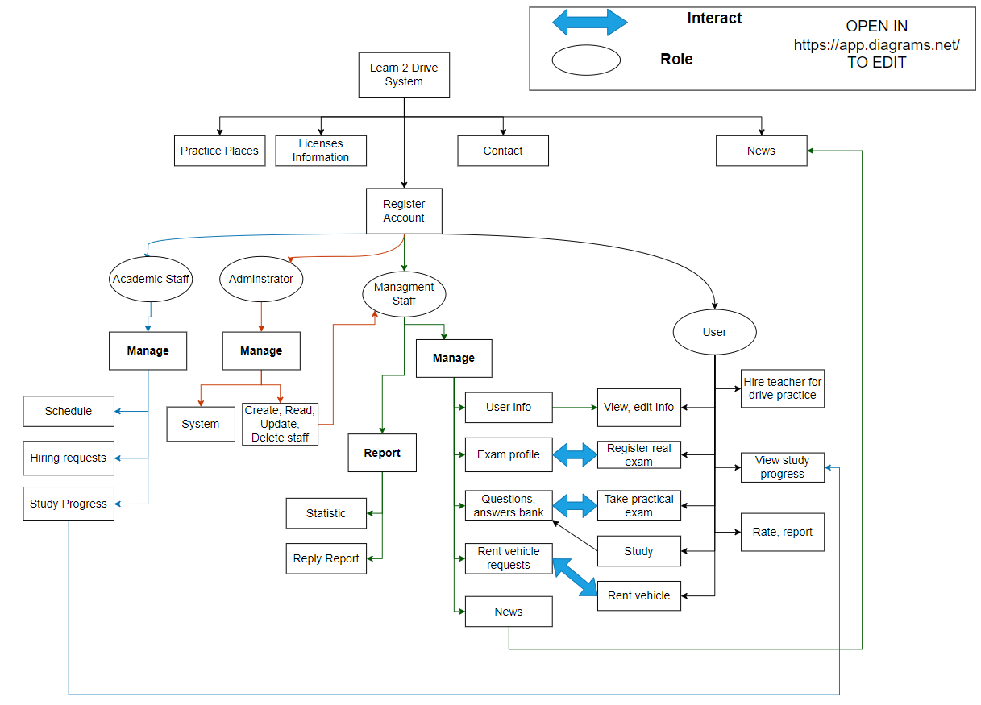

**Figure 1.** Sitemap for Learn2Drive

## Scope of Initial and Subsequent Releases

| **Feature** | **Release 1** | **Release 2** | **Release 3** |
| --- | --- | --- | --- |
| FE-1: View information about all license types. | News for each license type | Links to participate in the multiple choice tests based on each license type | Editable information for admin, improve the quality of content |
| FE-2: Study and see the latest updated questions and answers | Take multiple choices trial tests | View trial test info: correct/ incorrect questions, grade | Fully implemented |
| FE-3: Take a live practice test with the same format as the real test | Not implemented | Implemented if time permits | Fully implemented |
| FE-4: Rent a car and register for instructors to teach directly on the . | Users can find vehicles to rent | Admin can change the information of the rent vehicles |  |

## Limitations and Exclusions

LI-1: The may not cover all aspects of the driver's license exam, or may not be suitable for all learners.

LI-2: The may not be available in all languages or countries.

LI-3: The may not be accessible to all users, including those with disabilities.

# Business Context

## Stakeholder Profiles

| **Stakeholder** | **Major Value** | **Attitudes** | **Major Interests** | **Constraints** |
| --- | --- | --- | --- | --- |
| Customer (driving license applicants) | To get a valid driving license after passing the exam | Positive, eager, anxious | To have a fair, convenient, and reliable exam system | Time, cost, availability, accessibility |
| Project manager | To deliver the system on time, within budget, and with quality | Responsible, proactive, communicative | To manage the project scope, schedule, resources, and risks | Scope creep, stakeholder expectations, resource allocation |
| Project team (developers, testers, etc.) | To develop and test the system according to the requirements and standards | Skilled, collaborative, creative | To have clear and consistent requirements, feedback, and support | Technical challenges, changing requirements, testing environment |
| Sponsor (government agency or department) | To provide funds and resources for the project | Supportive, authoritative, demanding | To have a return on investment, alignment with strategic goals, and compliance with regulations | Budget, timeline, quality standards |
| Supplier (third-party vendors or contractors) | To provide essential services or equipment copyright for the project | Cooperative, competitive, profitable | To have a long-term partnership, timely payment, and clear specifications | Contract terms, delivery schedule, quality assurance |

## Project Priorities

| **Dimension** | **Constraint** | **Driver** | **Degree of Freedom** |
| --- | --- | --- | --- |
| **Features** | All features scheduled for release 1.0 must be fully operational |  |  |
| **Quality** | 95% of user acceptance tests must pass; all security tests must pass |  |  |
| **Schedule** |  |  | Release 1 planned to be available by end of Q1 of next year, release 2 by end of Q2; overrun of up to 2 weeks acceptable without sponsor review |
| **Cost** |  |  | Budget overrun up to 15% accept able without sponsor review |
| **Staff** |  | Team size is half-time project manager, half-time BA, 3 developers, and 1 tester; additional developer and half-time tester available if necessary |  |

## Deployment Considerations

The system allows the driving license applicants to take multiple choice trial tests before the actual exam. This feature helps them to assess their knowledge and skills, and to identify their strengths and weaknesses. The system provides feedback and suggestions for improvement after each trial test. The system also keeps track of the applicants’ progress and performance over time. The system leverages the benefits of both technologies, such as fast development, scalability, security, and performance.